Promotional Items:
- Gadget Spinner, GA-18013CL (image 1)
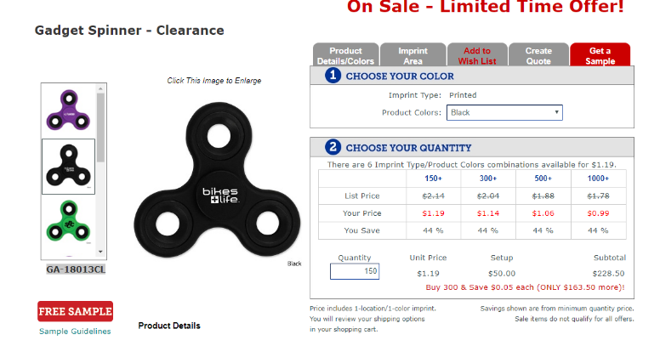
- Eco Spiral Notebook & Pen, WPE-1004 (image 2)
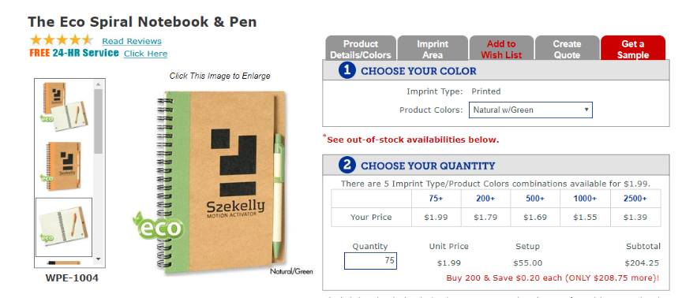

Uniforms:
- Ladies Interlock Cardigan, L807, $29.98 (image 1 – far left)
  - Okay value, thicker material.
- ¼-Zip Sweatshirt with Cadet Collar, 4528M, $27.10 (image 2)
  - Okay value, going to be thicker material, was one of the originals
we were considering last semester.
- ¼-Zip Pullover, ST357, $15.98 (image 3)
  - Best value, light weight athletic material.
- ½-Zip Pullover, F224, $23.98 (image 4 – far right)
  - Good value, light weight micro fleece material, will be incredibly soft.
